# 1 Install Intellij IDEA

version 2019.1

# 2 download javafx library

<https://gluonhq.com/products/javafx/>

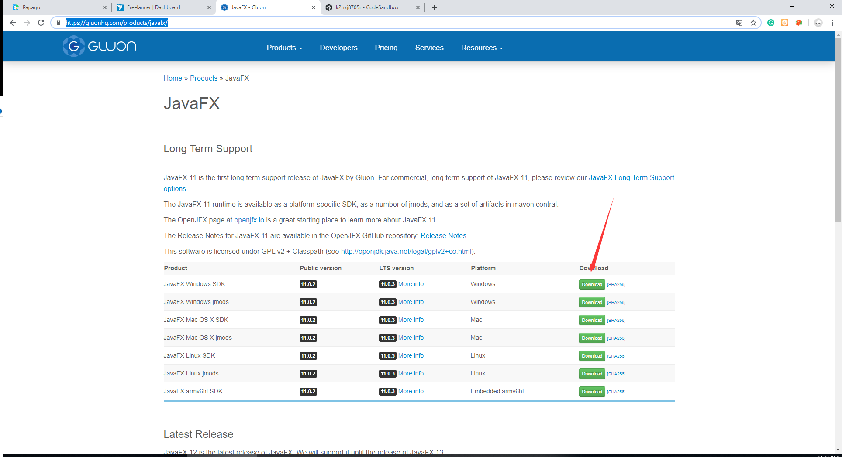

# 3 install jdk-8u211-windows-i586.exe

# 4 . Run Inteill and open project.

# 5 . Follow me.

